March 2nd, 2011

MEASURING STRESS REDUCTION USING
FAR INFRARED RAY MEDICAL DEVICE BIOMAT FOR 12 SUBJECTS

AUTHOR: DR. GEORGE GRANT, Ph. D, I.M.D., M.Sc., M.Ed., C. CHEM., R.M.

Affiliation: Currently in private practice at Champion Integrative Clinic, Toronto, ON Canada. Former Consultant for Health Canada, Ottawa, ON, Professor at Seneca College, North York, ON and Scientist at the faculty of Pharmacy, Saskatoon, Sask., Canada.

March 2nd 2011

Title:
Measuring stress reduction using Far Infrared Medical Device Biomat for 12 subjects

Author:
Dr. George Grant, Ph.D., I.M.D., M.Sc., M.Ed., C. Chem., R.M.

Affiliation:
Currently in private practice at Champion Integrative Clinic, Toronto, ON Canada. Former Consultant for Health Canada, Ottawa, ON, Professor at Seneca College, North York, ON and Scientist at the faculty of Pharmacy, Saskatoon, Sask., Canada.

Abstract:
12 subjects were tested before and after using the Biomat for one hour daily over 3 months period using 3 different biofeedback devices and blood Cortisol levels to measure stress reduction.
Far Infra Red/Negative Ions Amethyst Biomat reduces Stress by 78% as validated by Pre and Post Biofeedback Brain Scans as well as fating blood test to measure the stress hormone Cortisol.

The core of Biomat technology is a combination of far infrared ray, negative ion effects and the conductive properties of amethyst channels. These three powerful health stimulators are combined in a single, easy-to-use product with remarkable healing properties.
The Biomat delivers soothing, deep-penetrating heat while stimulating the regeneration of damaged cells in your body. It’s a safe and natural way to achieve optimal health now and maintain a stronger, more resilient body in the future. This highly effective therapy is now available to medical professionals and home consumers who want to improve health and well-being with products based on Nobel prize-winning scientific research pioneered by NASA and developed using pure, natural materials. The Biomat is an approved medical device by FDA.

Benefits of the Infra red ray and Negative Ions emits by Amethyst Biomat:
Reduces stress and fatigue, relieves anxiety and promotes relaxation, improves sleep patterns,
reduces inflammation, eases joint pain and stiffness, provides warm, soothing pain relief, eliminates toxins in the body, increases blood circulation, alleviates migraines and tension headaches, reduces allergy symptoms, improves immune system function, improves cardiovascular health, burns calories and controls weight and improves muscle tone and skin quality.

12 subjects were tested before and after using the Biomat for an hour daily over 2 months using ICAP Brain Scan, HRV Heart scan and Bio resonance Magnetic analyzer.
The results were reduction in stress by 78% among subjects tested and an increased sense of well being. All 12 subjects were tested in Toronto, ON Canada.
Author Contact information and Biography:
Name: Dr. George F. Grant, Ph. D., I.M.D.
Address: 17 Waterhouse Way
Richmond Hill, Ontario L4C9H8 Canada
Telephone: 905 737 1788
Email: drgramt@rogers.com
Website: www/academyofwellness.com

Biography:
Prof. Dr. George Grant is the Canadian Pioneer of Quantum Integrative Medicine.
His 36 years in the academia, government and private practice makes him a peerless expert in Stress, pain and Biofeedback. He has published in the areas of Pharmacy, Chemistry, Microbiology, Toxicology, Nutrition, Biofeedback, Stress and Natural Pain Management. Dr. Grant is an Integrative Medical Specialist, world-class professional speaker, corporate trainer, and author. Former Professor and senior consultant for Health Canada. Analytical Chemist, Toxicologist, Microbiologist, Nutritionist, biofeedback, Stress Management, Pain management, anti aging and Indoor Air Quality Specialist. Founder of the Academy of wellness, 1982. Author of 7 Best-selling books, former Scientist at U of Sask. Faculty of Pharmacy/Nutrition & Professor at Seneca College in Toronto, senior consultant for Health Canada. He has 100 published articles, conference presentations, book reviews and 7
Best-selling books.
Dr. Grant completed his doctorate degree from the university of Toronto, ON; Obtained a doctorate in Integrative Medicine from the Board of Orthomolecular and Integrative Medicine [BOIM]; Masters Degree from Brock University Maters of Science in Food Chemistry, Microbiology, and Toxicology from the University of Sask.; B.Sc. University of British Columbia in Food Sc. & Nutrition; Batchlor of Technology, BCIT; and B.Sc.in Biochemistry.

Complete resume is attached as requested.

Original Work:
This case study is an original work and has not been submitted for publication in any other scientific journal or online publication.

Subject Selection Criteria:
12 healthy subjects with mild to moderate stress were selected to participate in this case study and signed an informed consent. Subjects with medical, psychiatric conditions and those with heavy medications were excluded from the study.
Subjects were tested using bio feedback devices before and after using the bio mat daily every week and a blood test to measure Cortisol levels was obtained from each subject before and after 3 months at the completion of the case study.

Introduction:
The core of Biomat technology is a combination of far infrared rays [6-12 microns], negative ion effects and the conductive properties of amethyst channels. These three powerful health stimulators are combined in a single, easy-to-use product with remarkable healing properties. The Biomat manufactured and distributed by Richway International Inc. delivers soothing, deep-penetrating heat while stimulating the regeneration of damaged cells in the body. This highly effective therapy is now available to medical professionals and home consumers who want to improve health and well-being with products based on Nobel prize-winning scientific research pioneered by NASA and developed using pure, natural materials.

U.S.A.FDA 510K Medical Device K072534
Japan FDA Medical Device BG 1030097
Korea FDA Medical Device A83080.01

Materials & Methods:
Biofeedback devices used to measure stress reduction:
- Quantum Resonance Magnetic Analyzer [QRMA]: measures Electromagnetic waves emitted by human bodies which represent condition of cells, tissues and organs. The data is compared with standard spectrum to detect imbalances and measure stress reduction. This biofeedback device provides the stress of vital key organs and systems.
Test Results provides a range of
Mild………….… [0-30]
Moderate ………[30-60]
Severe stress ….. [70-100].

- ICAP [wireless Brain Scan EEG]
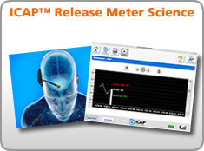
Fig.1 ICAP Release Meter to measure stress zone

To monitor brain imbalance & blockages & Stress
The ICAP™ Release Meter System is made up of the EEG sensor, the signal transmitter, the USB base station that captures the signal, the proprietary algorithm that translates the raw data from the transmitter (Release Vector) and the visual representation of that data in the ICAP™ Release Meter software. The system also incorporates the Release® Technique, a method used to retrain the brain’s responses. The device provides 3 distinct stress zones as well as an average stress score at the end of the measurement. A value of less than 500 indicates manageable stress, 500-700 medium stress and from 700 to 900 high stress. A value over 950 indicates extremely high stress.

HRV [Wireless Heart Scan ECG]: This HRV Test implements a battery of three tests as the most comprehensive and informative combination of tests for Autonomic Nervous System [ANS] purposes to measure stress:
1. Orthostatic test as the initial method for ANS provocation;
2. Valsalva maneuver combined with deep Breathing as the optimal method for revealing the hidden abilities of the Autonomic function and distinguishing between chronic and temporary abnormalities;
3. Real-time Nerve-Monitor test as the ultimate method for ANS assessment in long-term therapy, continuous monitoring.
Test Results provides 3 cardiovascular zones: Red [high risk] of heart disease in the lower right zone [low fitness + low physiology [0-3], white [medium risk][medium fitness + medium physiology][3-7] in the middle zone and blue [low risk][high fitness + high physiology][7-10] in the upper left zone for athletes.
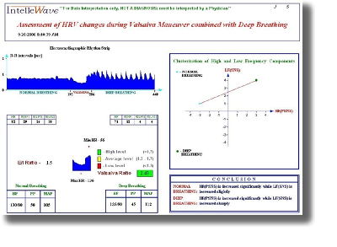
Fig.2 Heart Scan Diagram to measure cardiovascular physiology[x axis] & fitness [y axis]

Blood Cortisol Test Results: A Cortisol test is done to measure the level of the Cortisol in the blood.
Normal results may vary from lab to lab.
CORTISOL
Morning | 5-23 mcg/dL
Afternoon | 3-13 mcg/dL

Fig. 3 The Controller of the Biomat (Time and Temperature control)

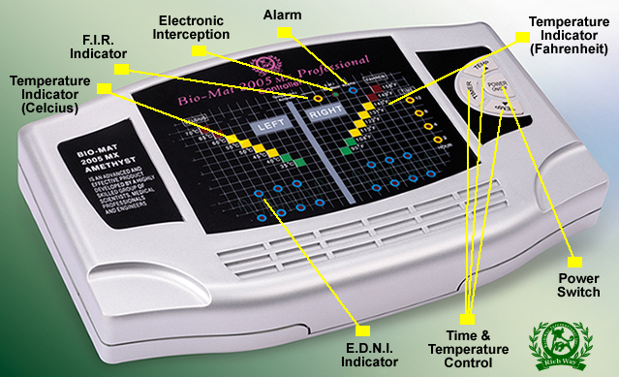

Table 1 Summary of Results

Subject Number 1:
[HR] A retired female executive who is on high blood pressure [Altace] medication, water pill [Hydrochlorothyzide] and medium dose Thyroid medication [Altroxin]. She has improved after using the Biomat for 3 months with noticeable improvement in her blood pressure and lower stress level as shown in her ICAP brain scan as well as her heart scan and reduction in Cortisol levels.
Subject Number 1 Chart:
Level  [mcg/dcl] | Pre Test Results  Before use the Biomat | Post Test Results  After use the Biomat
QRMA  [0-100] | 55 | 42
ICAP  [100-1000] | 625 | 475
HRV  [1-10] | 2 | 4
Blood Cortisol  [5-25] | 19 | 13

QRMA / ICAP/HRV /BLOOD CORTISOL LEVEL IS CHANGED
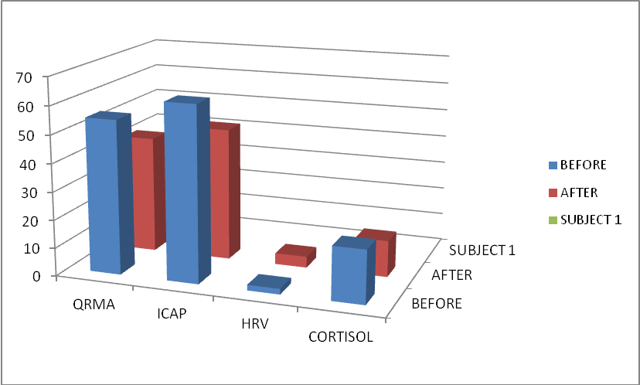

Subject Number 2:
[DJ] A male in his mid sixty recovering from bypass surgery and taking 4 medications: blood thinner [Plavix]. Lipitor for high cholesterol, Pantaloc for acid reflux and Valium for sleep problems, he did not notice a difference in the first 3 weeks but after 5 weeks, he reported better sleep and less chest pain from angina. In his third month he stopped his sleeping pill and his doctor took him off Lipitor due to improved HDL cholesterol and lower LDL cholesterol and Cortisol. His INR was stable and he needed less dose of Plavix than when he started his Biomat study. His heart improved by 20% even though he did not exercise during the 3 month test except for frequent walking 2 times a week as recommended.

Subject Number 2 Chart:
Level  [mcg/dcl] | Pre Test Results  Before use the Biomat | Post Test Results  After use the Biomat
QRMA  [0-100] | 78 | 56
ICAP  [100-1000] | 845 | 615
HRV  [1-10] | 3 | 5
Blood Cortisol  [5-25] | 20 | 17

QRMA / ICAP/HRV /BLOOD CORTISOL LEVEL IS CHANGED
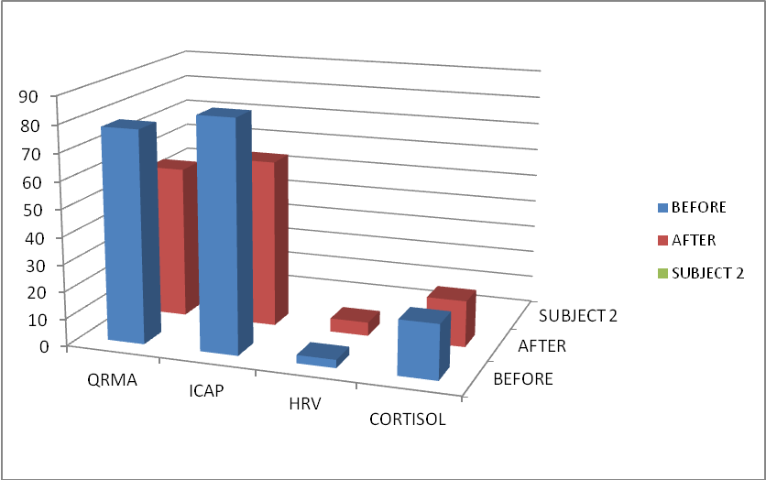
Subject Number 3:
[EG] A mid life healthy female with no medication, she had mild knee and back pain which improved after the 3 months test on the Biomat. She also reported less stress as shown in her biofeedback scan, brain scan and heart scan.

Subject Number 3 Chart:
Level  [mcg/dcl] | Pre Test Results  Before use the Biomat | Post Test Results  After use the Biomat
QRMA  [0-100] | 56 | 68
ICAP  [100-1000] | 435 | 375
HRV  [1-10] | 5 | 6
Blood Cortisol  [5-25] | 13 | 10

QRMA / ICAP/HRV /BLOOD CORTISOL LEVEL IS CHANGED
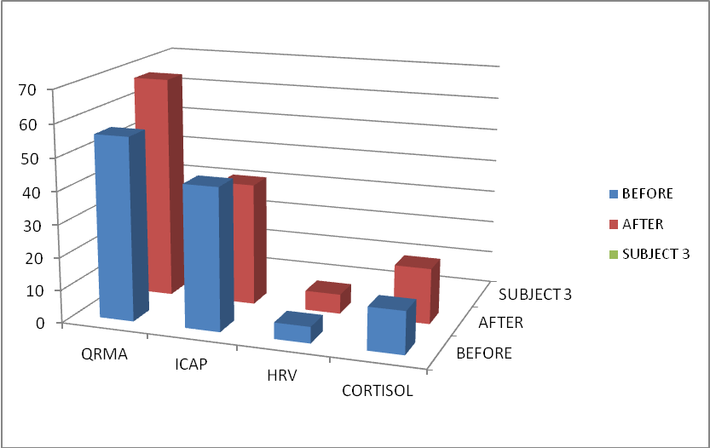

Subject Number 4:
[MW] A healthy young male with no medication but minor pain and moderate stress, he reported less stress and pain after only 2 weeks of using the Biomat as shown in his results.

Subject Number 4 Chart:
Level  [mcg/dcl] | Pre Test Results  Before use the Biomat | Post Test Results  After use the Biomat
QRMA  [0-100] | 75 | 40
ICAP  [100-1000] | 670 | 425
HRV  [1-10] | 4 | 6
Blood Cortisol  [5-25] | 16 | 12

QRMA / ICAP/HRV /BLOOD CORTISOL LEVEL IS CHANGED
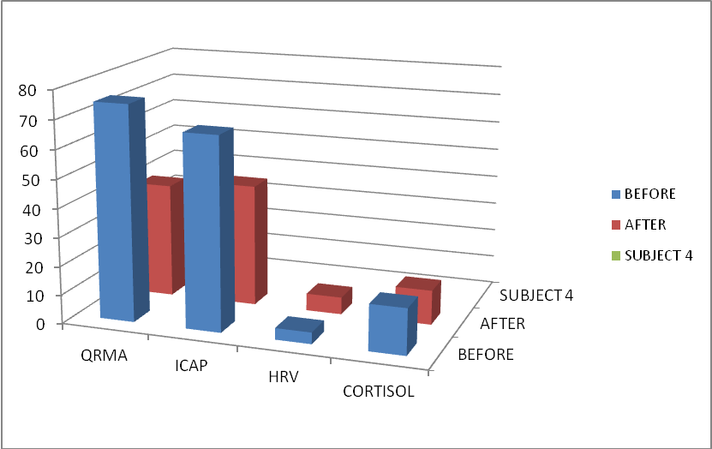

Subject Number 5:
[SB] A middle aged woman who had car accident and severe neck and back pain her stress was high but felt less stress after 4 weeks of using the Biomat.

Subject Number 5 Chart:
Level  [mcg/dcl] | Pre Test Results  Before use the Biomat | Post Test Results  After use the Biomat
QRMA  [0-100] | 76 | 65
ICAP  [100-1000] | 835 | 645
HRV  [1-10] | 1 | 3
Blood Cortisol  [5-25] | 16 | 12

QRMA / ICAP/HRV /BLOOD CORTISOL LEVEL IS CHANGED
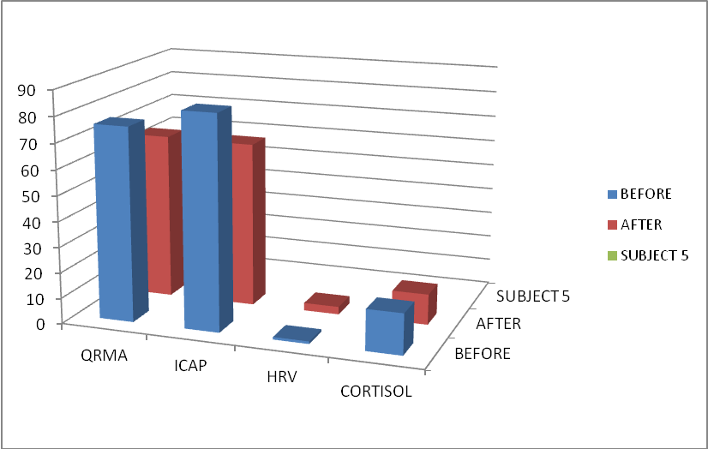

Subject Number 6:
[SB] A mid life woman who had a car accident and severe neck and back pain her stress was high but felt less stress after 4 weeks of using the Biomat.

Subject Number 6 Charter:
Level  [mcg/dcl] | Pre Test Results  Before use the Biomat | Post Test Results  After use the Biomat
QRMA  [0-100] | 40 | 31
ICAP  [100-1000] | 425 | 315
HRV  [1-10] | 5 | 6
Blood Cortisol  [5-25] | 16 | 14

QRMA / ICAP/HRV /BLOOD CORTISOL LEVEL IS CHANGED
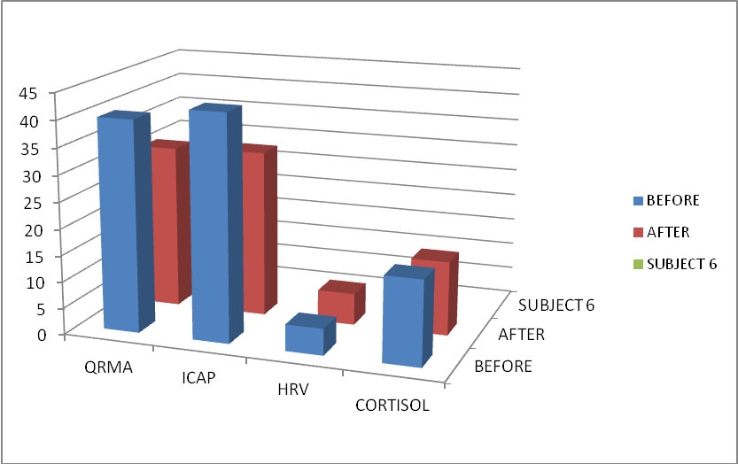

Subject Number 7:
[DK] A young female with PMS cramps and high stress that was ameliorated after using the bio mat. She was using mild pain killers but stopped taking medication after 5 weeks of using the Biomat.

Subject Number 7 Charter:
Level  [mcg/dcl] | Pre Test Results  Before use the Biomat | Post Test Results  After use the Biomat
QRMA  [0-100] | 42 | 28
ICAP  [100-1000] | 476 | 355
HRV  [1-10] | 7 | 7
Blood Cortisol  [5-25] | 11 | 10

QRMA / ICAP/HRV /BLOOD CORTISOL LEVEL IS CHANGED
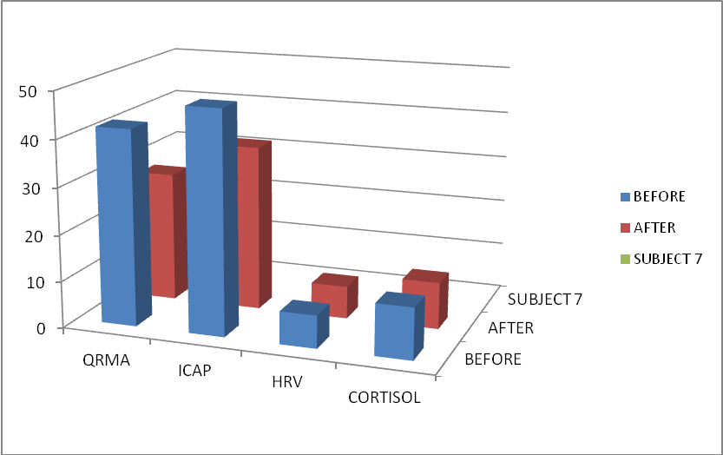

Subject Number 8:
[HH] A healthy young woman with no medication but very high stress with 5 children’s stress and sleep habits improved dramatically in her second month of using the Biomat.

Subject Number 8 Charter:
Level  [mcg/dcl] | Pre Test Results  Before use the Biomat | Post Test Results  After use the Biomat
QRMA  [0-100] | 66 | 38
ICAP  [100-1000] | 560 | 475
HRV  [1-10] | 2 | 6
Blood Cortisol  [5-25] | 16 | 13

QRMA / ICAP/HRV /BLOOD CORTISOL LEVEL IS CHANGED
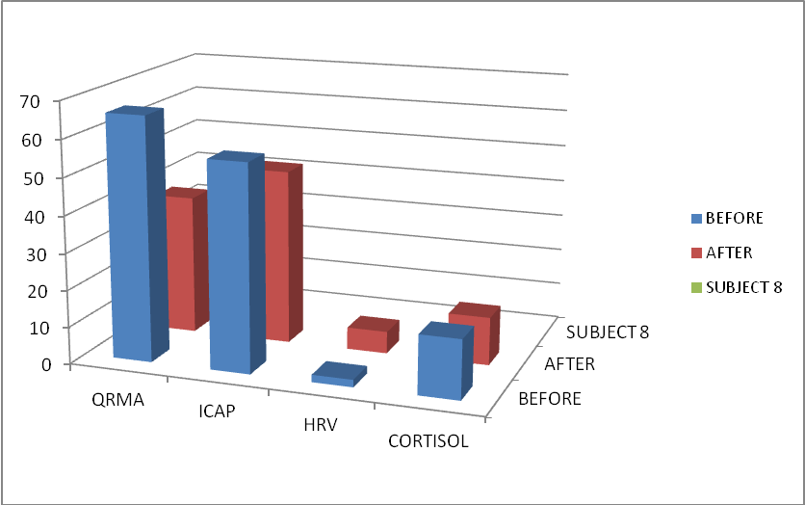

Subject Number 9:
[JS] An old male with 6 medications and high stress, he cut back on his medications and also lost 10 LB after using the Biomat for 3 months. His stress level was reduced and he noticed better sleep pattern with no need for sleep medication.

Subject Number 9 Charter:
Level  [mcg/dcl] |  | Pre Test Results  Before use the Biomat |  | Post Test Results  After use the Biomat
QRMA  [0-100] |  | 68 |  | 44
ICAP  [100-1000] | 575 |  | 385
HRV  [1-10] | 2 |  | 6
Blood Cortisol  [5-25] | 16 |  | 9

QRMA / ICAP/HRV /BLOOD CORTISOL LEVEL IS CHANGED
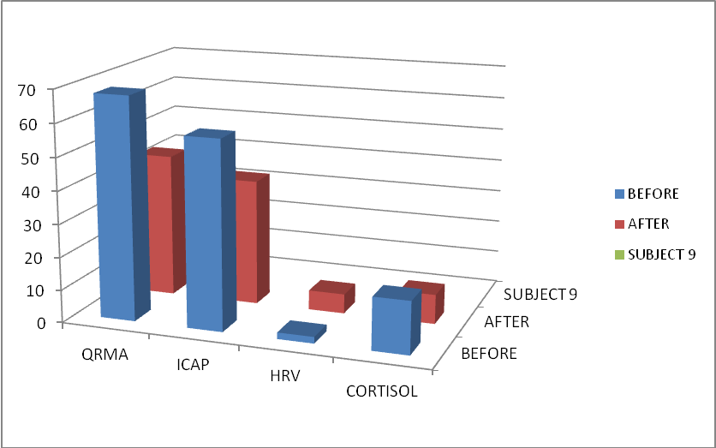

Subject Number 10:
[YL] A heavy and old female with poor dietary habits, she was consuming 5 cups of coffee and 2 sodas daily. Her stress was high with poor sleeping habits. She experienced chest pain and her score in the HRV was in the red zone. She had made remarkable improvement after 2 months on the Biomat and she was told also to change her life style habits. She initially scored very low in our wellness assessment tool at www.academyofwellness.com and then doubled her score after modifying her life style habits. All chest pain was gone and her ECG score was much better.

Subject Number 10 Charter:
Level  [mcg/dcl] | Pre Test Results  Before use the Biomat | Post Test Results  After use the Biomat
QRMA  [0-100] | 78 | 55
ICAP  [100-1000] | 960 | 710
HRV  [1-10] | 1 | 3
Blood Cortisol  [5-25] | 22 | 15

QRMA / ICAP/HRV /BLOOD CORTISOL LEVEL IS CHANGED
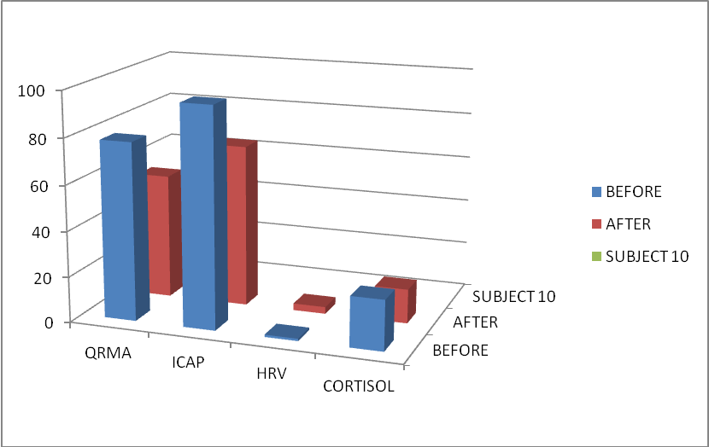

Subject Number 11:
[WS] A young healthy male with no medications and healthy life style but very high stress and poor sleeping habits, his stress was improved after using the Biomat for 3 month and doing frequent exercise. His sleeping habits did not improve since he works mid night shift.

Subject Number 11 Chart:
Level  [mcg/dcl] | Pre Test Results  Before use the Biomat | Post Test Results  After use the Biomat
QRMA  [0-100] | 85 | 60
ICAP  [100-1000] | 925 | 640
HRV  [1-10] | 2 | 4
Blood Cortisol  [5-25] | 18 | 12

QRMA / ICAP/HRV /BLOOD CORTISOL LEVEL IS CHANGED
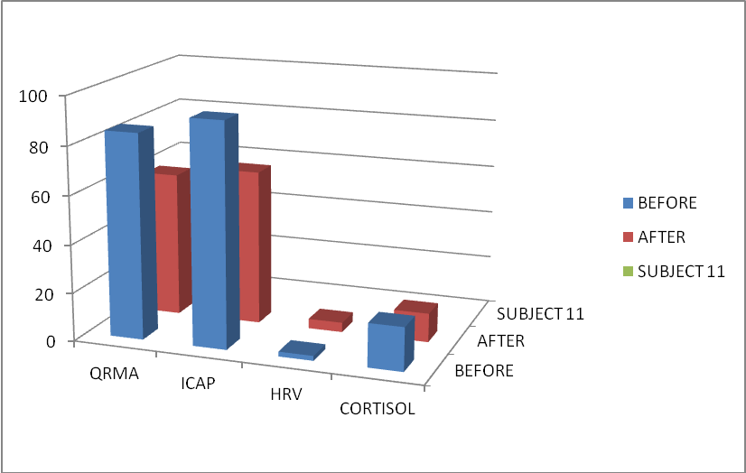

Subject Number 12:
An old female who takes 5 medications for Arthritis [Celebrex], blood pressure [Norvasc], cholesterol [Crestor], sleeping pill [Ativan] and acid reflux [Nexium]. After using the Biomat for 3 months and avoiding acid foods, she lost 20 LB and felt much better with no medications. Her own physician was pleased with her fast progress and positive outlook.

Subject Number 12 Chart:
Level  [mcg/dcl] | Pre Test Results  Before use the Biomat | Post Test Results  After use the Biomat
QRMA  [0-100] | 55 | 35
ICAP  [100-1000] | 425 | 310
HRV  [1-10] | 5 | 7
Blood Cortisol  [5-25] | 16 | 12

QRMA / ICAP/HRV /BLOOD CORTISOL LEVEL IS CHANGED
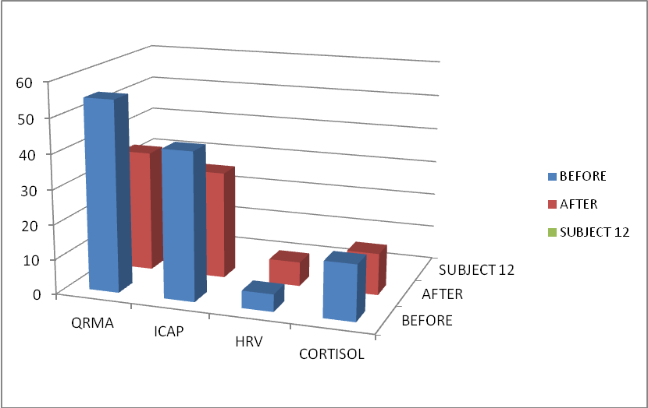

Discussion

Average Improvement (Increased and Decreased)
It appears from the above case study that the 12 subjects received 78% on average improvement in stress reduction, better sleep, less Cortisol and overall improvement particularly when they change also their lifestyle habits. The test results from the biofeedback devices correlated well with each other as well as with the Cortisol blood test results.

Improvement Chart (Reduced QRMA, ICAP, CORTISOL and Increased HRV)

QRMA DECREASED FROM 64.5 TO 46.8
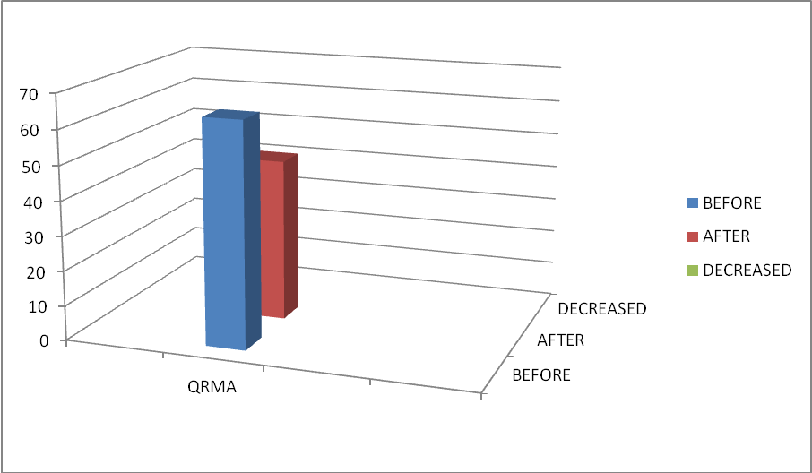

ICAP DECREASED FROM 646 TO 477
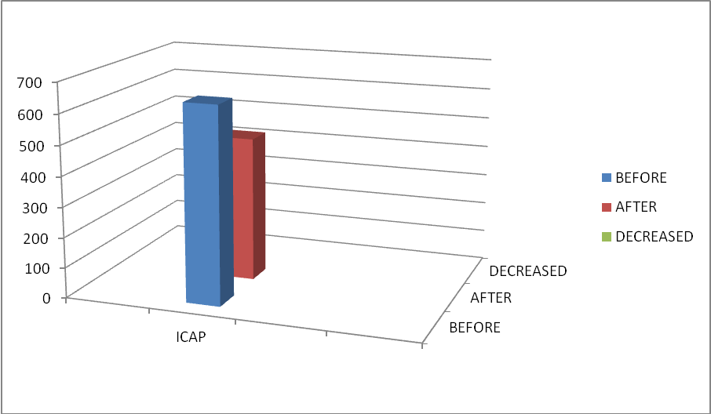

HRV INCREASED FROM 3.25 TO 5.25
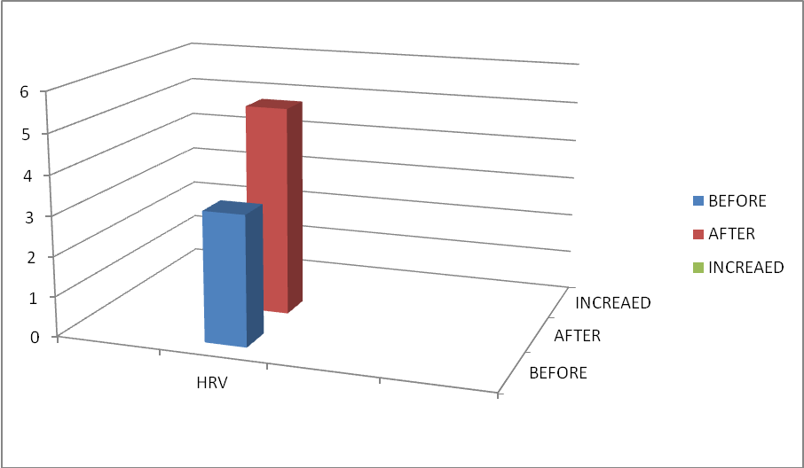

BLOOD CORTISOL LEVEL DECREASED FROM 16.7 TO 12.5
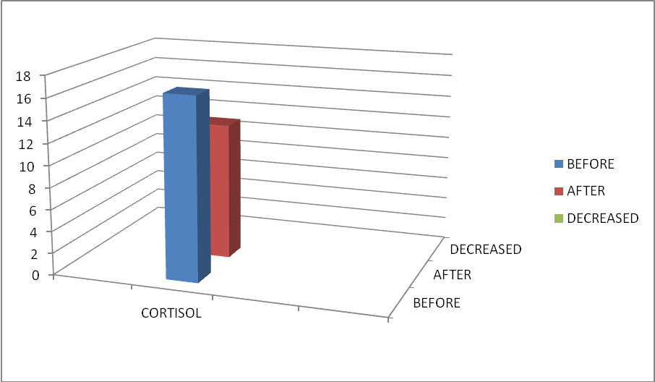

The Cortisol level may show problems with the adrenal or pituitary glands. Cortisol is made by the adrenal gland. Cortisol levels go up when the pituitary gland releases another hormone called (ACTH).
Cortisol has many functions. It helps the body use sugar (glucose) and fat for energy and it helps the body manage stress. Cortisol levels can be affected by many conditions, such as physical or emotional stress, strenuous activity, infection, or injury.
Normally, Cortisol levels rise during the early morning hours and are highest about 7 a.m. They drop very low in the evening and during the early phase of sleep. But if you sleep during the day and are up at night, this pattern may be reversed

Cortisol and Fat Cell:
Cortisol regulates energy by selecting the right type and amount of substrate (Carbohydrate, fat or protein) that is needed by the body to meet the physiological demands that is placed upon it. Cortisol mobilizes energy by tapping into the body’s fat stores (in the form of triglycerides) and moving it from one location to another, or delivering it to hungry tissues such as working muscle. Under stressful conditions, Cortisol can provide the body with protein for energy production through Gluconeogenesis, the process of converting amino acids into useable carbohydrate (Glucose) in the liver.

Additionally, it can move fat from storage depots and relocate it to fat cell deposits deep in the abdomen. Cortisol also aids Adipocytes (Baby fat cells) to grow up into mature fat cell. Finally, Cortisol may act as an anti-inflammatory agent, suppressing the immune system during times of physical and psychological stress.

Cortisol directly effects fat storage and weight gain in stressed individuals. Tissue Cortisol concentrations are controlled by a specific enzyme that converts inactive cortisone to active Cortisol. This particular enzyme is located in adipose (fat) tissues. Studies with human visceral (fat surrounding the stomach and intestines) and subcutaneous fat tissue have demonstrated that the gene for this enzyme is expressed more by obese conditions. It has also been demonstrated in research that human visceral fat cells have more of these enzymes compared to subcutaneous fat cells. Thus, higher levels of these enzymes in these deep fat cells surrounding the abdomen may lead to obesity due to greater amounts of Cortisol being produced at the tissue level.

As well, deep abdominal fat has greater blood flow and four times more Cortisol receptors compared to subcutaneous fat. This may also increase Cortisol’s fat accumulating and fat cell size enlarging effect.

Hans Selye, a foremost stress physiologist of the 20th century defined stress as “….the nonspecific response of the body to any demand made upon it.” Richard Lazarus, another highly regarded psychologist adds that stress is “…any event in which environmental demands, internal demands, or both tax or exceed the adaptive resources of an individual, social system, or tissue system.”
In many different societies, stress is a common term that is often associated with negative situations and settings. Yet, a stress-free life may also be harmful, because an individual will lose his/her ability to react to the different challenges of life. Every person has an optimal positive stress level referred to as stress, while stress that is harmful is noted to be distress.

People can react to a stressor in different ways. For instance, if an individual perceives the stressor as a challenge to his/her control of a situation, Norepinephrine the “fight” hormone is predominantly released. And, if the stress arousal increases and a possible loss of control is felt by the individual, then epinephrine, another “flight/anxiety” hormone is released.

When the stress is prolonged and seen as hopeless, the individual becomes more distressed and feels defeated. This activates the hypothalamus in the brain. What follows is a cascade of hormonal pathways resulting in the final release of Cortisol from the adrenal cortex (of the kidney).

The brain has the ability to selectively activate the fight, flight, or defeat responses. This usually occurs in day to day living when an individual perceives his/her hassles as a challenge to control or a loss of control. Although the stress pathways work together, they each can uniquely affect the function of bodily processes. For instance, the “fight” or “flight” stress responses cause the heart to beat faster and harder as well as release more free fatty acids (disassembled triglycerides) into the blood.

The “defeat” response stress pathway can lead to enhanced Lipogenesis (fat creation), visceral obesity (deep abdominal obesity), breakdown of tissues, and suppression of the immune system. As shown from the results of this case study, the bio mat has resulted in the stress reduction for the 12 subjects by reducing Cortisol, the stress hormone and increasing serotonin and endorphins known as the happy chemicals in our brain.

Far Infrared ray emitting by Biomat increases blood circulation and oxygen supply to damaged tissues (aiding reduction of chronic joint and muscle pain or sport injuries), promotes relaxation and comfort, induces sleep and relieves stress as shown in this case study.

Recently there have been reports detailing the hazards of exposure to certain kinds of electromagnetic fields, such as those from high-tension power lines, cell phones, or from computer display terminals. Far Infrared heating systems have been tested in Japan and found free of toxic electromagnetic fields. The Swedish National Institute of Radiation Protection has also concluded that infrared heaters are not dangerous. Instead, Japanese researchers have reported that far infrared radiant heat antidotes the negative effects of toxic electromagnetic sources.

References:
Alberts B. The molecular biology of the cell (2nd edition), New York: Garland Press. 1990

Kaltsas H. (2009). What is ionization? Retrieved February 14, 2010

Grant George, Ph.D. Doctoral thesis, University of Toronto, Stress Factors affecting college educators, 1995

Grant George, M.Ed. Thesis, Brock University, Measuring stress affecting college professors, 1992

Jones DP. Redefining Oxidative stress Antioxidant Redox Signal. 2006, 8 (9-10):1865-1879.

Tribune Business News, p.l. Piller, N. (1999, September).

The scientific basis and Therapeutic benefits of far infrared ray therapy

Health Food Association, 1-7.Richardson, W. Spiritual values and gemstones

Marina Del Ray: Devorest Company. 1998.

Acknowledgement: The author would like to thank Richway International for providing the Bio Mats to conduct the study and also for all volunteers participated in this study. We would like to thank all biofeedback devices who agreed to use their devices for measuring stress in this study.

